

Task Order 19

Saxton Lab Simulation Capability

VISSIM External Driver Model Add-On for the Simulation of Connected Automated Vehicle Applications



**Project Number: DTFH61-12-D-00020**

**Submitted: November 8, 2015**

**Version: 1**

**Table of Contents**

1 Introduction 1

1.1 Background 1

1.2 Framework Architecture 2

2 Case Study: Automated Longitudinal Vehicle Control (ALVC) 5

2.1 ALVC Introduction 5

2.2 Software/Hardware Requirements for ALVC Simulation 8

2.3 VISSIM Network and Simulation Manager Setting 9

2.4 Overview of GUI for ALVC Simulation Manager 17

2.5 External Driver Model API for ALVC 20

Appendix A SVN Instructions 28

# Introduction

## Background

The concept of Connected Vehicles (CV) is based on real-time information sharing between vehicles and infrastructure, using communications technologies such as cellular networks (3G/4G/LTE) or vehicle Dedicated Short Range Communications (DSRC). CV applications have been studied extensively in the past decades, and researchers have developed and evaluated many applications, such as queue warnings (Nowakowski, 2012) and collision warnings (Hu & Lin, 2009).

The success of the individual vehicle control lays the foundation for more advanced control that governs interactions among multiple “connected vehicles”, usually referred to as Connected Automated Vehicles (CAV) and the resultant impact on highway traffic performance. For instance, efforts have been made to extend ACC to Cooperative Adaptive Cruise Control (CACC) to further improve a vehicle’s following efficiency through multi-vehicle communication taking into account stability (Vugts, 2010), traffic throughput (Van Arem, 2005), and energy and environmental impacts (Malakorn & Park, 2010).

Previous research efforts on CAV applications appear to show promise in improving the capacity and safety of roadway, but methodologies of evaluating the applications are not mature. In the literature, there are only a few studies dedicated to methods of evaluating CVs, focusing more on integration with a widely accepted traffic simulator (e.g., VISSIM, AIMSUM), information sharing (data exchange and types of messages for BSM, Basic Safety Messages), communication properties, and certain traffic management strategies based on rich data sources (e.g., signal timing) (Malakorn & Park, 2010; Tanikella et al., 2007; Zhang et al., 2010). No such efforts have been made in the literature on the simulation framework for evaluating CAV’s impacts on roadway and traffic performance, and a CV framework is inadequate for simulating CAVs. One of the major reasons is that CAVs tend to have significantly different driving behavior from human drivers, which is modeled with traditional car-following models (e.g., Wiedemann model) in commercial traffic simulators. Evaluation of CAV applications requires dedicated driver models that can simulate special CAV behaviors, such as platooning based on real-time communications between vehicles.

As USDOT and state DOTs are launching new programs of CAV research and potential future field tests/deployments, it is useful to build a standardized CAV modeling and simulation framework, with which we have the flexibility to evaluate a variety of CAV applications with minimized efforts. This framework should also provide an extensible library that represents the basic knowledge necessary to do the innovative tasks associated with machine driving behavior. As more applications are tested and developed on the basis of the framework, the library can be continuously extended and offer more flexibility of CAV simulation. Further, we make this knowledge accessible to students and researchers by providing/describing a GUI to facilitate learning and experimentation, and detailed model structure and data flows. A mid-level engineer with moderate experience of traffic simulation should be able to pick up the tool, teach himself and evaluate potential CAV applications. While this project focuses on providing a self-instructional user guide for the evaluations of any CAV applications, a case study conducted in this project deals with a particular CAV application, namely Automated Longitudinal Vehicle Control (ALVC).

This project report is organized as follows. In the remainder of this section, an overall architecture of the CAV evaluation framework is presented with three major components: 1) VISSIM simulation software package, 2) Simulation Manager, and 3) driver model Application Programming Interface (API). In Section 2, a case study dealing with the ALVC application is demonstrated through a self-instructional user guide for the CAV evaluation framework in detail.

## Framework Architecture

Major Component

To implement various CAV applications, three major modules are required: the VISSIM Network module, the Simulation Manager module, and the API module. The overall framework is illustrated in Figure 1.

* + - * 1. VISSIM Network is the transportation network to be used for testing a large variety of CAV algorithms.
        2. Simulation Manager (SM) is a graphical user interface developed to support easy scenario building to conduct multiple simulations. The detailed instructions of SM are presented in Section 2.
        3. The API module is a program that determines driver behavior by programming corresponding parameters. The API module is discussed in Section 3.

VISSIM Simulation Package

VISSIM, developed by *PTV Planung Transport Verkehr AG*, is a multi-modal traffic flow simulation software. It is capable of conducting microscopic simulation where each entity (e.g. car, train, pedestrian) is simulated individually. Such a capability is one of the most crucial elements for CAV concept implementation and evaluation.

Simulation Manager

The Simulation Manager enables users to easily adjust control parameter values that are crucial for the implementation of CAV applications in VISSIM without directly accessing the VISSIM driver model API source codes. It also provides users with an interface to conveniently modify simulation scenario parameters, such as market penetration rates, traffic volumes, and simulation times.



Figure CAV Evaluation Tool Architecture

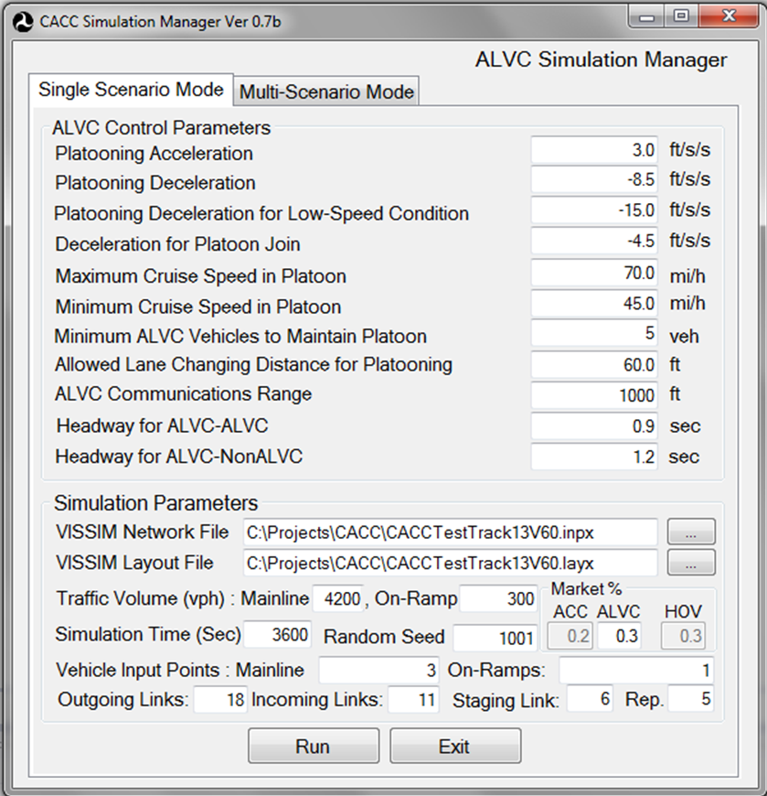

Figure Simulation Manager Interface

Driver Model API

VISSIM is capable of not only conducting conventional simulation of transportation behavior in a network, but also implementing its External Driver Model through Dynamic Linked Library (DLL) Interface, which substitutes the driving behavior built in VISSIM by a fully-user-defined behavior for vehicles. In a properly set up framework, VISSIM passes the current state of a vehicle and its surrounding traffic to the DLL; the DLL computes and determines the succeeding behavior of the vehicle as an algorithm specifies; and then the DLL passes the updated state of the vehicle back to VISSIM for the next simulation period.

# Case Study: Automated Longitudinal Vehicle Control (ALVC)

## ALVC Introduction

As one of the most promising CAV technologies, Automated Longitudinal Vehicle Control (ALVC) technology has gained great attention for its promising capability to dramatically improve the mobility performance of roadways by increasing capacity and reducing travel time. Given the two-way wireless communications capability under the CAV environment, ALVC enables leading and following vehicles that are equipped with proper V2V communication devices in the same lane to keep short time headways (i.e., 1-second or shorter) while they cruise at high speeds (i.e., 60 MPH or higher). ALVC can be implemented as a V2V communication device, wherein the leader informs the follower of its location, speed, and acceleration, allowing the follower to safely follow the leader at a shorter time gap. The follower can safely and quickly respond to speed changes by the leading vehicles, thereby reducing the risk of rear-end collisions. Speeds and gaps are adjusted by vehicle weight and performance.

Finally, ALVC can be implemented as an ad hoc platooning concept, wherein several vehicles form a “platoon” that behaves as a single unit. The real-time driving information of each vehicle is collected using V2V wireless communications. The optimal driving maneuvers to maintain the headways are generated based on the driving information collected by each pair of leading-following vehicles. Under the ALVC mode, given the optimal maneuvers, vehicles’ target speeds are automatically adjusted to keep the headways.

A high-level control algorithm architecture for ALVC vehicles is shown in Figure 3. Based on a feedback control scheme, the algorithm continuously adjusts the acceleration/deceleration rates by measuring the headway between the leading and the subject vehicles by using two-way communications in the connected vehicle environment. In the event that the leading vehicle is not equipped with ALVC, the control algorithm of the following vehicle works as an Adaptive Cruise Control (ACC). ALVC is used as an example for demonstrative purposes to conduct any potential “*what-if*” scenarios under various experimental factors as follows:

- Market penetration rates of communications device for ALVC

- Mainline traffic congestion level

- On- and off-ramp traffic volumes

- Interchange configuration

- Methods of forming and maintaining an ALVC platoon

- ALVC headways



Maintaining vehicle platoon

ALVC vehicle joining platoon

Figure 3 High-level Control Algorithm Architecture for ALVC

In the ALVC Add-On package, three grouping schemes for new ALVC vehicles, such as rear, front, and cut-in Joins, as depicted in Figure 4, are implemented. The rear join leads a new ALVC vehicle to follow the last vehicle of an ALVC group driving along the most adjacent lane of the joining vehicle. Thus, the joining vehicle searches for an adjacent ALVC vehicle group consisting of at least two ALVC vehicles. In the event that the joining vehicle identifies an ALVC group running in the other lane, the vehicle manipulates the vehicle based on the lane changing model of VISSIM to change into the target lane where the identified platoon is moving. Note that the lane changing behavior of non-ALVC vehicles is determined by VISSIM’s lane changing behavior model.

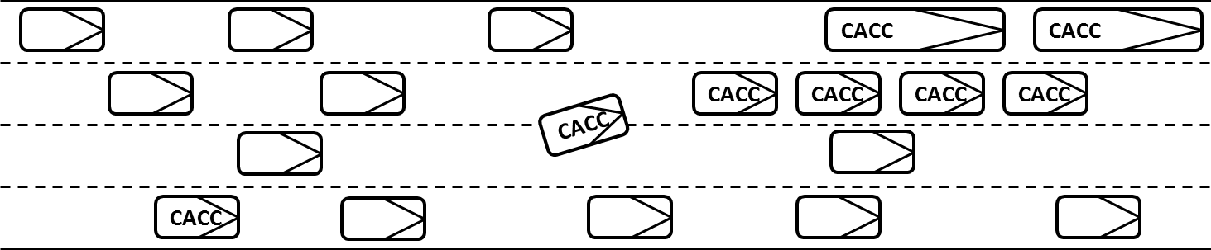

(a) Rear Join

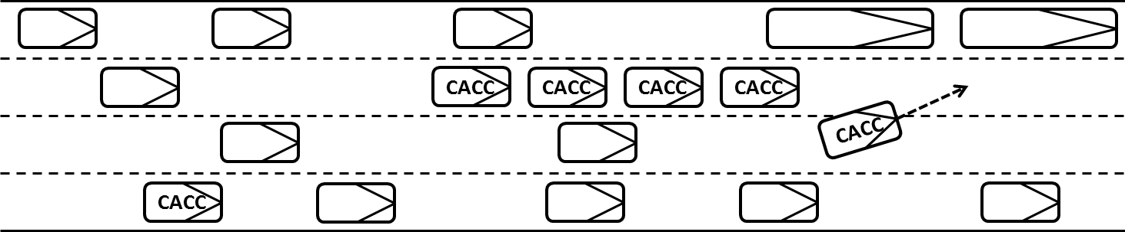

(b) Front Join

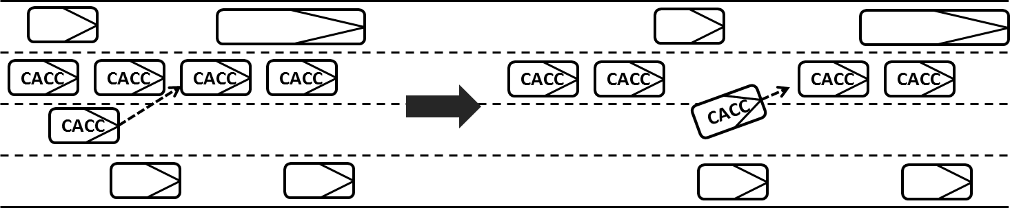

(c) Cut-in Join

Figure ALVC Grouping Methods

The front join performs the same process to allow a new ALVC vehicle to join into an existing ALVC group except that it leads the joining vehicle to the front of the first vehicle in the ALVC group. The cut-in join method is implemented by cooperatively adjusting the maneuvers of the joining vehicle and an ALVC vehicle in the group. Thus it is implemented only if a platoon composed of at least two ALVC vehicles exists. As shown in Figure 4(c), once the joining vehicle identifies a target ALVC group, it approaches the group and determines a proper position to be inserted based on its current driving information such as speed, acceleration rate, etc. Then the deceleration rate of an ALVC vehicle in the target group, which is located behind the insertion point, is adjusted to create a safe gap for the joining vehicle while the leading vehicle maintains its current speed. If the safe gap is satisfied for the lane change behavior of the joining vehicle, which is governed by VISSIM’s lane changing model, the joining vehicle begins lane changing until it is completely grouped so that it can maintain the headway. Figure 5 demonstrates the scanning mechanism for the ALVC equipped vehicle in each decision-making interval while it is not in a platoon.



Figure ALVC Scanning for Equipped Vehicles

## Software/Hardware Requirements for ALVC Simulation

The ALVC Add-On package runs in the VISSIM simulation environment by using VISSIM’s external driver model API. Currently, the API module in the ALVC Add-On has been tested with VISSIM version 6[1]. Minimum requirements to conduct ALVC simulation are as follows.

- PTV VISSIM Version 6.X

- VISSIM DriverModel.dll

- Windows 7 or newer

- 512 MB of RAM

- 500 GB of Hard Drive Disk

- .Net Framework Version 3.5 or newer

- Visual Studio 2010 or higher

To ensure successful implementation of our example codes, it is suggested that the following software set is used. This set-up is used in the software development.

- PTV VISSIM Version 6.19

- Windows 7 64 bit

- Visual Studio 2013

## VISSIM Network and Simulation Manager Setting

Provided that the physical network is ready, the following settings are required to conduct the most basic simulation. For more details about each component of the network settings, one can refer to VISSIM’s User Manual.

Step 1: Adding ALVC Vehicle Type

* 1. Go to Base Data\Vehicle Types. Once the Vehicle Types tab is activated, the user can see the seven type default vehicles (including pedestrians) in the list.
  2. Right click the mouse and select “Add.”

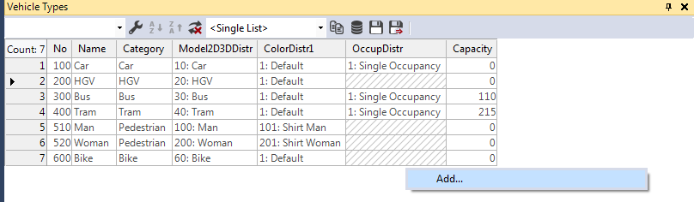

Figure Adding ALVC Vehicle Type

Step 2: Naming ALVC Vehicle Type

In the pop-up window, type in the No. and Name of the new vehicle type (e. g. Vehicle Type No.: 101, Vehicle Type name: ALVC). Other vehicle characteristics can also be adjusted in this window.

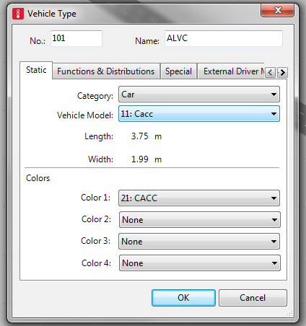

Figure Name of the ALVC Vehicle

Step 3: Confirm the addition of the intended type of vehicle to the list

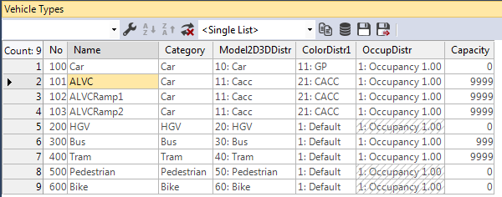

Figure Successful Addition of ALVC Vehicle Type

Step 4: With the same procedure, the user can add ALVC vehicle on the ramp

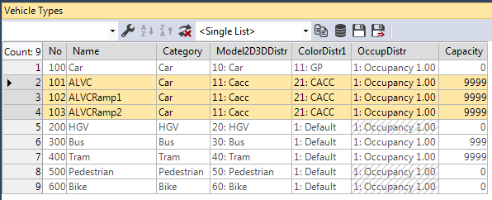

Figure Successful Addition of ALVC Vehicle Type on Ramps

Step 5: In Vehicle Types list, right click the ALVC type of vehicle, go to Edit

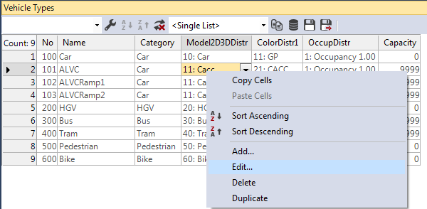

Figure Editing Vehicle Characteristic

Step 6: Configure External Driver Model

In the Vehicle Types editor window, go to External Driver Model tag, enable Use external driver model, and locate the path for DriverModel.dll. (e.g., C:\ALVC\DriverModel_DLL\Bin\Debug\DriverModel.dll. Note that the DLL file should be compiled on the same computer using Visual Studio. The instruction for compilation is in Section 2.5).

If the box of “Use external driver model” is checked, the driving behavior of all vehicles of this vehicle type will be calculated by the selected DLL. A subdirectory “DriverModelData” must exist in the directory of vissim.exe in order to avoid a warning message when VISSIM is started.

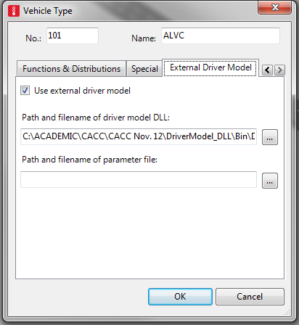

Figure Import the External Driver Model

Step 7: Adjust vehicle length for ALVC vehicles

1. Go to Base Data>Distributions>2D/3D Model  
   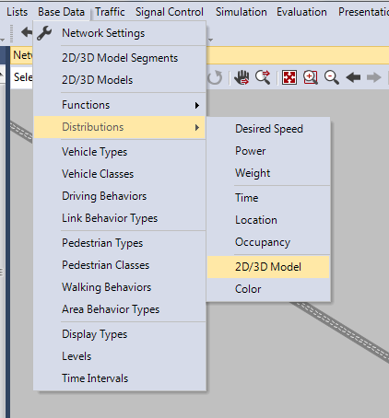

Figure Configuring the 2D/3D Model

1. Select ALVC-equipped Vehicle: create a new type of vehicle with a particular vehicle length. If this does not exist, you need to create it yourself. Refer to VISSIM User Manual for details.

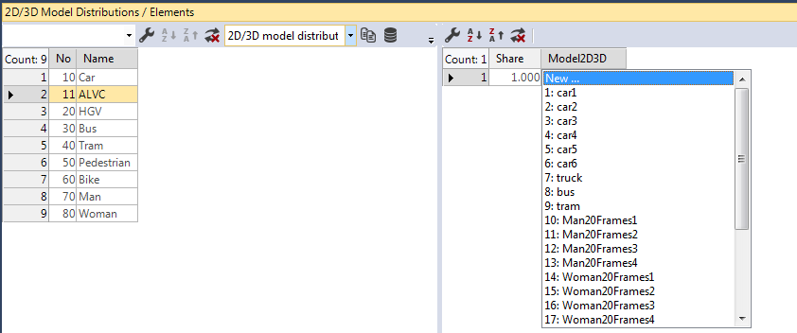

Figure Selecting a Vehicle Type

1. Select one vehicle type in the list (e.g. Toyota Yaris)

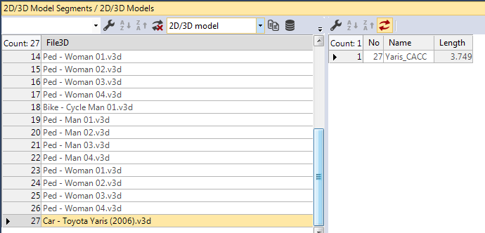

Figure Selected a Type of Vehicle with Particular Length

Step 8: Locating a solution (.sln) file

Simulation Manager is what a user should use to start VISSIM simulation and change simulation/driver model parameters. Figure 15 shows how you can access the main “.sln” file.

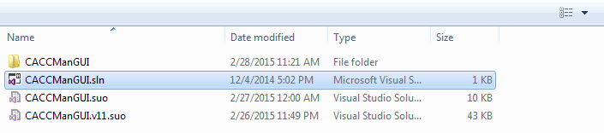

Figure Locate the Visual Studio Solution File

Step 9: Add Reference (if applicable)

If you are running this code for the first time on your machine or if you have recently re-installed VISSIM, VISSIM library needs to be added before running the code. In “Solution Explorer” (located on the right side of the Visual Studio window), find and delete “VISSIMLIB” under “Reference” as shown in Figure 16.

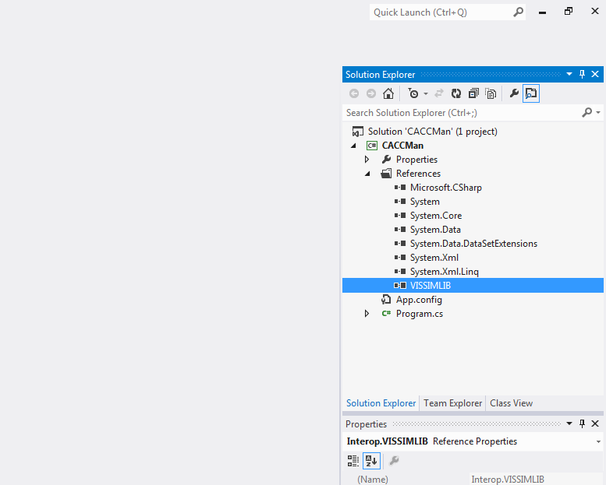

Figure Confirm the Existence of the Vissim Library Reference

Then, right click “Reference,” select “Add Reference” to open the “Reference Manager” window, search “VISSIM” under “COM,” and select/add the “VISSIM Object Library 6.0” as shown in Figure 17.

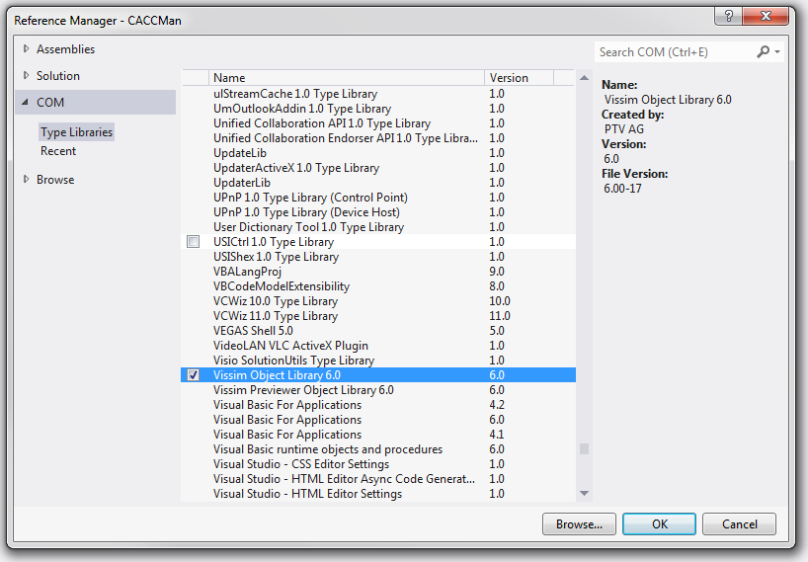

Figure Select and Add the Vissim Object Library

Step 10: Run the program

Click “Start” to run the program.

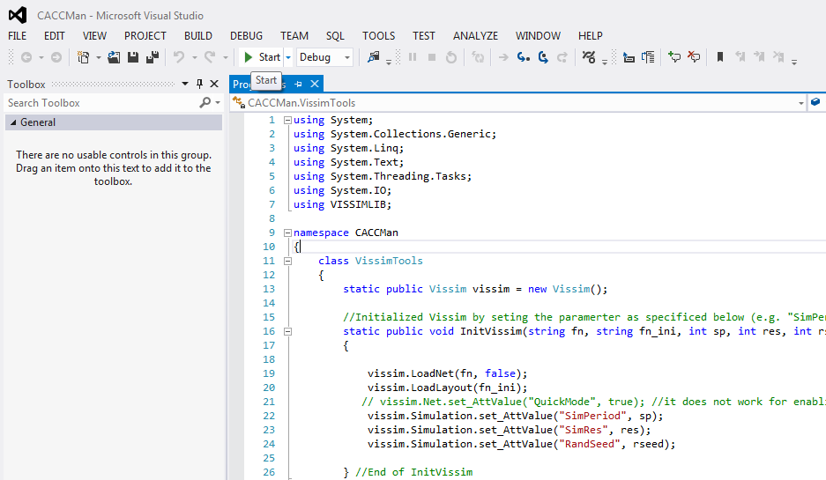

Figure Start the Simulation Manager

## Overview of GUI for ALVC Simulation Manager

The ALVC Simulation Manager was comprised of a Single Scenario Mode and a Multi-Scenarios Mode. It is noted that the Multi-Scenario mode will be completed in the future. In the Single Scenarios Mode, it contains two panels: ALVC Control Parameters panel and Simulation Parameter Panel. The ALVC control parameters panel deals with crucial components required for implementing longitudinal control of automated vehicles in the VISSIM simulation model. Remember to locate your own “VISSIM Network File” and “VISSIM Layout File.”



Figure ALVC Simulation Manager

**Simulation Parameter**

Table ALVC Control Parameter

|  |  |
| --- | --- |
| Parameter | Definition |
| Platooning Acceleration | The acceleration rate of ALVC vehicle to estimate headway in the platoon for the next simulation step, ft/s/s |
| Platooning Deceleration | The deceleration rate of ALVC vehicle for the next simulation step, ft/s/s |
| Platooning Deceleration for low-speed condition | The deceleration rate of ALVC vehicle in the platoon for the next simulation step when its speed is below pre-determined speed threshold |
| Deceleration for Platoon Join | The deceleration rate of an ALVC vehicle to join a platoon |
| Maximum Cruise Speed in Platoon | The maximum cruising speed of ALVC vehicle in the platoon, mph |
| Minimum Cruise Speed in Platoon | The minimum cruising speed of ALVC vehicle in the platoon, mph |
| Minimum ALVC Vehicles to Maintain Platoon | The minimum number of vehicle to maintain a platoon |
| Allowed Lane Changing Distance for Platoon | Minimum gap (distance) between two ALVC vehicle in a platoon to allow Cut-In Join |
| ALVC Communications Range | The effective communication range between any pair of DSRC-equipped vehicles, ft |
| Headway for ALVC-ALVC | The headway between two ALVC-equipped vehicles, seconds |
| Headway for ALVC-NonALVC | The headway between an ALVC and non-ALVC vehicles, seconds |

Table Simulation Parameters

|  |  |
| --- | --- |
| Parameter Group |  |
| VSSIM file path | VISSIM Network File: specify the path of the network file, appendix “.inpx” |
| VSSSIM Layout File: specify the path of the network layout file, appendix “.layx” |
| Vehicle input parameters | Vehicle Input Point-Mainline: specify the number of vehicle input point(s) on main line |
| Vehicle Input Point-On-Ramps: specify the number of on-ramps with vehicle input point |
| Traffic Volume Mainline: The hourly volume for the vehicle input point |
| Traffic Volume On-Ramp: specify the traffic volume for the on-ramp(s), if multiple volumes of different time intervals exist, use a comma to separate the volume in ascending order. (e.g. “600,480”) |
| Simulation parameter parameters | Simulation Time: The total time period for the simulation in seconds |
| Random Seed: The seed used for the simulation to ensure simulation variability |
| Replications: specify the number of simulation runs under the same random seed |
| Vehicle composition parameters | ACC: percentage of ACC (adaptive cruise control) vehicles in a particular vehicle input point |
| ALVC: percentage of ALVC (cooperative adaptive cruise control) vehicles in a particular vehicle input point |
| HOV: percentage of HOV (high-occupancy vehicle) in a particular vehicle input point |
| ALVC Decision making links parameters | Outgoing Links: the link through which the vehicles exit the network. It is the link, determined by external driver model (ALVC model), where an ALVC-equipped vehicles switch off ALVC and exit the network |
| Incoming Links: the immediate link through which the vehicles enter the network. It is the link, determined by external driver model, where ALVC-equipped vehicles switch on ALVC mode and start looking for vehicle platooning opportunities |
| Staging Link: The movements of ALVC vehicle in a simulation model are automatically controlled by the ALVC API module. At the moment of the departures of ALVC vehicles, ALVC API module often causes unrealistic lane changing behavior, which is likely to adversely affect VISSIM’s internal lane changing behavior applied to non-ALVC vehicles. The staging link is to provide additional space for ALVC vehicles until they maintain stable lane changing conditions. 500~1000 ft of staging link is recommended. |

## External Driver Model API for ALVC

This section briefly describes the overall structure of the ALVC API source code along with its key variables and instructional steps to compile the source code. Table 3 summarizes key variables used for the implementation of ALVC simulation. For the overall structure of the API source code, one can refer to a code block diagram and the data flow among code blocks in Figures 23 and 24, respectively.

Table Variable Definitions of External Driver Model

| Variable | Description | Note |
| --- | --- | --- |
| desired_acceleration | Desired acceleration rate |  |
| desired_lane_angle | Desired angle for lane changing | Radian |
| active_lane_change | Direction of an active lane change.  +1 = to the left, 0 = none, -1 = to the right |  |
| rel_target_lane | Destination lane by lane changing. Destination Lane = current_lane – rel_target_lane | +: right lane  -: left lane |
| desired_velocity | Desired speed | ft/sec |
| turning_indicator | Lane changing indicator. 0: No Lane Changing. 1: Change to a left lane. -1: Change to a right lane. |  |
| vehicle_color | Vehicle color code | Up to RGB(255,255,255) |
| veh_type | Vehicle type number |  |
| current_link | Link ID where the subject vehicle is located. |  |
| current_lane | Lane ID where the subject vehicle is located. |  |
| lanes_current_link | Adjusted lane ID to handle VISSIM’s lane numbering configuration rule. | The first lane of VISSIM is starting from the right-most lane. |
| timestep | Current simulation time |  |
| current_veh | Vehicle ID of the subject vehicle controlled by the API |  |
| vissim_suggestion | Mandatory lane changing decision by VISSIM. 0: No Lane Changing. 1: Change to a left lane. -1: Change to a right lane. | Refer to VISSIM DriverModel API Manual. |
| simple_lanechange | Optional lane changing decision by VISSIM. |
| AdjVehicles[5][5] | List of adjacent Vehicles’ IDs | Refer to Figure 5 for more details. |
| AdjVehiclesWidth[5][5] | List of Adjacent Vehicles’ Lengths. For VISSIM 5.4, it handles vehicle width. |
| AdjVehiclesSpeed[5][5] | List of adjacent Vehicles’ speeds |
| AdjVehiclesDist[5][5] | List of adjacent Vehicles’ distances from the subject vehicle |
| AdjVehiclesAcc[5][5] | List of adjacent Vehicles’ acceleration/deceleration rates |
| AdjVehiclesLaneChange[5][5] | List of adjacent Vehicles’ lane changing status |
| AdjVehiclesCurrentLane[5][5] | List of adjacent Vehicles’ driving lanes |
| AdjVehiclesTargetLane[5][5] | List of adjacent Vehicles’ driving lanes |
| VehStatus | Status indicator for platoon joining activity. 1~5: platooning joining mode. 0: otherwise |  |
| PreviousVehAcc | Previous status of ALVC joining activity | Obsolete for the current API version. |
| VehTargetLane | Destination lane ID of ALVC vehicle when lane changing is activated. |  |
| VehTag | Lane changing indicator for ALVC vehicle in the next simulation step. 1: changing lane, 0: otherwise |  |
| VehToAdjustDecForCutIn | Adjusted deceleration rate of the subject ALVC vehicle to make space for cut-in join in the platoon. | By decelerating, this ALVC vehicle increases the gap from the following ALVC vehicle. |
| CACCLeader | Vehicle ID of the top-most vehicle of the current platoon that the subject ALVC vehicle is in |  |
| HowManyFollwers | Numbers of ALVC vehicles in the current platoon that the subject ALVC vehicle is in |  |
| LeadingVeh_ID | ID of the leading vehicle of the subject ALVC vehicle |  |
| LeadingVeh_Spd | Speed of the leading vehicle of the subject ALVC vehicle |  |
| LeadingVeh_Acc | Acceleration/Deceleration rate of the leading vehicle of the subject ALVC vehicle |  |
| DistLeadingVeh | Distance to the leading vehicle from the subject ALVC vehicle |  |
| DistTargetLeadingVeh | Distance from the subject ALVC vehicle to the leading ALVC vehicle on a destination lane for platoon joining |  |
| Spd_vehicle | Speed of the subject ALVC vehicle |  |
| Acc_vehicle ; | Acceleration of the subject ALVC vehicle |  |
| MaxAcc_vehicle | Max. acceleration of the subject ALVC vehicle |  |
| Headway_current | Current headway to the leading vehicle from the following ALVC vehicle |  |
| Headway_new | Updated headway to the leading vehicle from the following ALVC vehicle in the next simulation step |  |
| lateral_pos | Lateral position of the subject ALVC vehicle |  |
| lateral_pos_ind | Lane changing status indicator to determine whether the subject ALVC vehicle completes lane changing | If lateral position is between +0.2 and -0.2, it indicates lane changing is in progress |
| veh_od | Odometer of the subject ALVC vehicle | Obsolete |
| desired_acc_zero | Acceleration rate of ALVC vehicle to maintain uniform speed |  |
| init_acc | Initial acceleration rate of the subject ALVC vehicle |  |
| acc_time | Time span required for the estimation of the next step headway during the acceleration of the subject vehicle | Tenth of second: e.g., 30.0 = 3 sec |
| dec_time = | Time span required for the estimation of the next step headway during the deceleration of the subject vehicle |
| uniformspeed_time | Time span required for the estimation of the next step headway during the uniform speed of the subject vehicle |
| JoinCase | Indicator of platoon join case.  0: No join  1: Join a platoon in two-lane away to the left.  2: Join a platoon in one-lane away to the left.  3: Join a platoon in in the same lane.  4: Join a platoon in one-lane away to the right.  5: Join a platoon in two-lane away to the right. |  |
| VehToWatch | ID of an ALVC vehicle to record its trajectory in the API source code | For program debugging purposes |
| lane_angle | Lane changing angle (i.e., steering angle) for ALVC vehicle | 0.021 (Radians) |
| VehLengthIndicator | Variable for the API to distinguish ALVC vehicles from non-ALVC vehicles | Fixed to 3.749; thus, it must be synchronized with the corresponding VISSIM parameter |
| MinAllowLCDist | Minimum gap (distance) between two ALVC vehicles in a platoon to allow Cut-In Join | ***Allowed Lane Changing Distance for Platoon*** in the Simulation Manager GUI. |
| Headway | The headway between two ALVC-equipped vehicles | ***Headway for ALVC-ALVC*** in the Simulation Manager GUI. |
| Headway_No | The headway between an ALVC and non-ALVC vehicles, seconds | ***Headway for ALVC-NonALVC*** in the Simulation Manager GUI. |
| MaxLookAheadDist | The effective communication range between any pair of DSRC-equipped vehicles | ***ALVC Communications Range*** in the Simulation Manager GUI. |
| MInCACCSpdBound | The minimum cruising speed of an ALVC vehicle in the platoon | ***Minimum Cruise Speed in Platoon*** in the Simulation Manager GUI. |
| MinFollower | The minimum number of vehicles required to maintain a platoon | ***Minimum ALVC Vehicles to Maintain Platoon*** in the Simulation Manager GUI. |
| MaxSpdForCACC | The maximum cruising speed of an ALVC vehicle in the platoon | ***Maximum Cruise Speed in Platoon*** in the Simulation Manager GUI. |
| desired_dec_inc | Deceleration rate of an ALVC vehicle in the formed platoon | ***Platooning Deceleration*** in the Simulation Manager GUI. |
| desired_dec_inc_lowspd | Deceleration rate of an ALVC vehicle in the platoon for the next simulation step when its speed is below pre-determined speed threshold | ***Platooning Deceleration for low-speed condition*** in the Simulation Manager GUI. |
| desired_dec_inc_join | Deceleration rate of an ALVC vehicle to join a platoon | ***Deceleration for Platoon Join*** in the Simulation Manager GUI. |
| desired_acc_inc | Acceleration rate of an ALVC vehicle | ***Platooning Acceleration*** In the Simulation Manager GUI. |
| staging_link | ID of staging link in VISSIM network | Refer to Simulation Parameter section in Chapter 2 |

The compilation of ALVC API source code consists of 4 steps as follows:

Step 1: Start by opening the DriverModel Microsoft Visual Studio Solution file in the .dll package



Figure Locating the Driver Model File

Step 2: Go to Solution Explorer, activate DriverModel.cpp. Run Build Solution to compile the file.

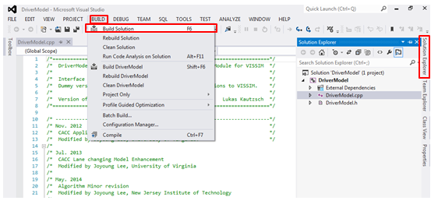

Figure Compiling the External Driver Model Source Code

Step 3: Locate the Bin folder in the package under Bin>Debug folder, where the compiled driver model can be found.



Figure Locate the Drive Model

Step 4: For loading the complied Driver Model into the network, refer to Step 6 *Configure External Driver Model* of *2.3 VISSIM Network and Simulation Manager Setting.*



Figure ALVC Code Block Diagram



Figure Data Flow among Code Bloc

# References

Hu, S.R., and J.-P. Lin, “Effects of Three Advanced Devices on Crash and Gate Breaking Prevention at Highway-Railroad Grade Crossings,” *Transp. Res. Rec. J. Transp. Res. Board*, pp. 1–15, 2009.

Malakorn, K. J., and B. Park, “Assessment of mobility, energy, and environment impacts of intellidrive-based Cooperative Adaptive Cruise Control and Intelligent Traffic Signal control,” *Proc. 2010 IEEE Int. Symp. Sustain. Syst. Technol. ISSST 2010*, 2010.

Nowakowski, C, D. Vizzini, S. Gupta, and R. Sengupta, “Evaluation of Real-Time Freeway End-of-Queue Alerting System to Promote Driver Situational Awareness,” *Transp. Res. Rec. J. Transp. Res. Board*, vol. 2324, pp. 37–43, 2012.

Tanikella, H., B. L. Smith, G. Zhang, B. Park, J. Guo, and W. T. Scherer, “Development and Evaluation of a Vehicle-Infrastructure Integration Simulation Architecture,” *J. Comput. Civ. Eng.*, vol. 21, no. December, pp. 434–440, 2007.

Van Arem, B., C. Driel, and R. Visser, “The impact of Co-operative Adaptive Cruise Control on traffic flow characteristics,” *Intell. Transp. Syst. IEEE Trans.*, vol. 7, no. 4, pp. 429–436, 2005.

Vugts, R. “String-stable cacc design and experimental validation,” vol. 59, no. 9, p. 115, 2010.

Zhang, G., B. L. Smith, M. Asce, and J. Guo, “Peer-to-Peer-Based Publish / Subscribe Architecture for Advanced Infrastructure Systems,” *J. Comput. Civ. Eng.*, vol. 24, no. 1, pp. 65–72, 2010.

# Appendix A SVN Instructions

The purpose of this appendix is to instruct potential future users at Saxton Lab at FHWA Turner Fairbank Highway Research Center on how to check out and update ALVC codes stored on the High Bay server.

**Step 1 Software Installation**

Download “TortoiseSVN” from the following link and install it on your computer. Please accept the default setup for installation. Choose the right version (32-bit and 64-bit) based on your personal computer configuration.

<http://tortoisesvn.net/downloads.html>

**Step 2 Mapping Network Drive to Build Connection**

Request an account (user name and password) on the I2 domain from Matt Gaillardetz ([Matthew.Gaillardetz.CTR@dot.gov](mailto:Matthew.Gaillardetz.CTR@dot.gov)).

Map network drive: The share path you need to map is \\10.10.30.35\JiaqiMa

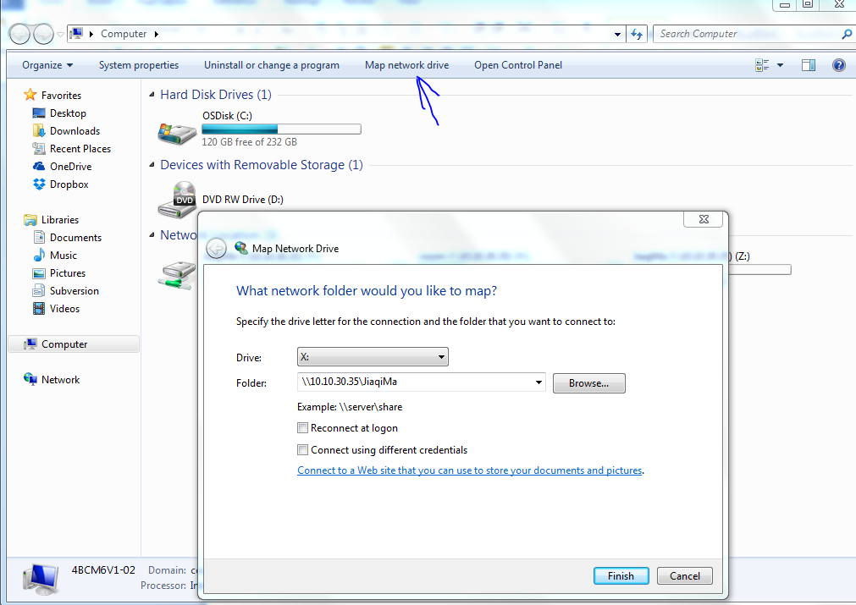

Figure A1 Network Drive Mapping Interface

**Step 3 Checkout Files**

1. Go to the mapped drive and find the folder named “repositories.” Go into the folder “repositories,” right click “TOPR19_ALVC_Files” and left click “SVN Checkout.” A “Checkout window” will pop up, as in Figure 2.
2. Keep the address under “URL of Repository” (the address of current folder address from your local computer) unchanged. Make sure the address is the address of the mapped driver on your local computer.
3. Change “Checkout directory” to the address of your local folder (folder “testtttt” in Figure 2), where you want to put the CACC code files. Note that this folder should be created beforehand for this purpose on your local computer, not in the mapped drive.
4. Leave other settings unchanged. Click OK and wait until the interface indicates “Checkout Finished!” as in Figure 3.

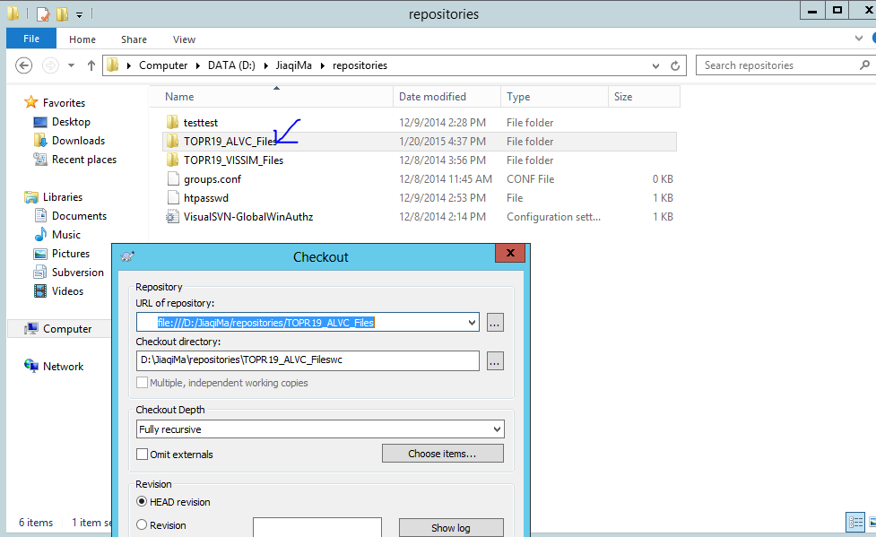

Figure A2 SVN Checkout Interface

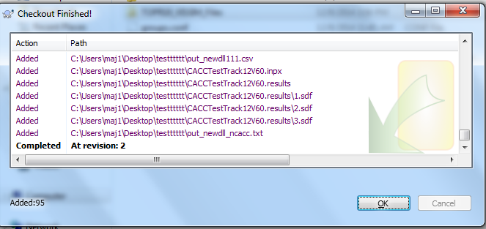

Figure A3 “Checkout Finished!” Interface

**Step 4 Update Files**

When the server codes are modified and you want to get an updated version, please do the following:

1. Go to the local folder
2. Right click anywhere (except files) and left click “SVN Update”

When you modify the codes and you want to update the server code, please do the following:

1. Go to the local folder
2. Right click anywhere (except files) and left click “SVN Commit”
3. Follow subsequent steps

Note that not all members can update the server codes. Please inform the PI and COR before you want to change the server codes.

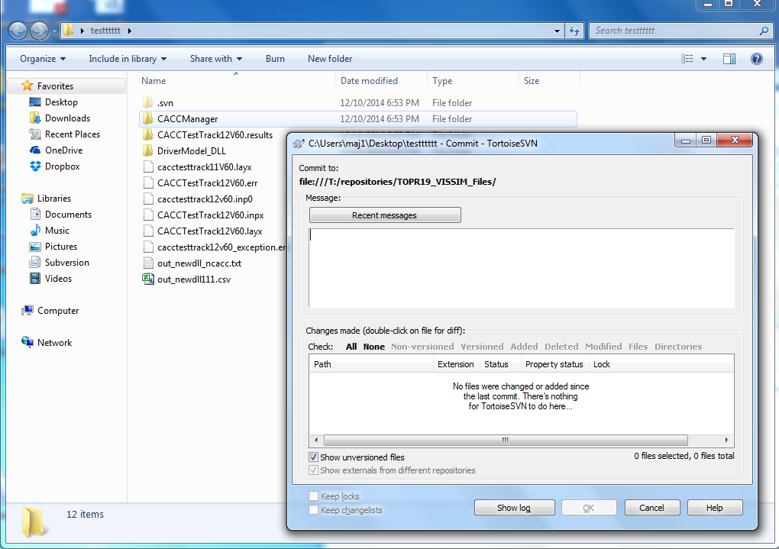

Figure A4 File Update (not recommended unless approved by the manager)

1. It is noted that VISSIM version 7 is not recommended for the ALVC simulation as it repeatedly crashed for unidentified reasons.

  